Linux commands for quick reference.

/dev, /proc, /sys – These are not normal folders, these are how you talk to kernel.
/dev/sda – your hard disk
/dev/tty – your terminal
/dev/null – a black hole file.
********************************************************************
/etc – the brain of linux. It stores all system configuration of the OS.
This is where users are stored, passwords are stored, how SSH login works, how servers boot automatically.
cat /etc/passwd – shows all users IDs of the linux filesystem
eg. Output : root:x:0:0:root:/root:/bin/bash
root – username
x – password stored elsewhere
0 – UID – SUPERUSER – if you create another user with UID – 0 , then it becomes root too.
0 – GID
Root – description
/root – home directory
/bin/bash – shell

cat /etc/shadow – this is where the user passwords are stored.
Eg. root:$y$j9T$...long-hash...:19673:0:99999:7::: - this is not password. This is a hash.

Linux never actually stores password.
When you login via SSH – you type password – linux hashes it – compares with /etc/shadow – if equal then access granted.
This is how SSH authentication works internally.

Second Secret : How Linux boots services automatically.

cat /etc -> systemd init.d rc0.d rc1.d rc2.d rc3.d rc4.d rc5.d rc6.d

When a server boots: Linux Kernel starts – then starts systemd.
systemd is the service manager. It decides:
. start ssh
. start networking
. start cron
. start docker
. start kubelet (Kubernetes node agent)
So when Kubernetes node comes up after reboot – it’s not Kubernetes magic. It’s Linux systemd running :
. kubelet.service
. containerd.service
. docker.service

Check running services (very important command)
sudo systemctl list-units –type=service | grep running

Third Secret: Networking configuration

cat /etc/hosts
cat /etc/resolv.conf
cat /etc/nsswitch.conf

Processes:
Linux is not a ‘file system OS’. Linux is actually a – process management system.
Everything in Linux exists to manage running programs.
A process = a running program in memory. Examples:
- nginx running: process
- ssh server: process
- docker: process
- kubelet: process
- even your terminal: process
Even bash you are typing in is a process.

ps -ef :

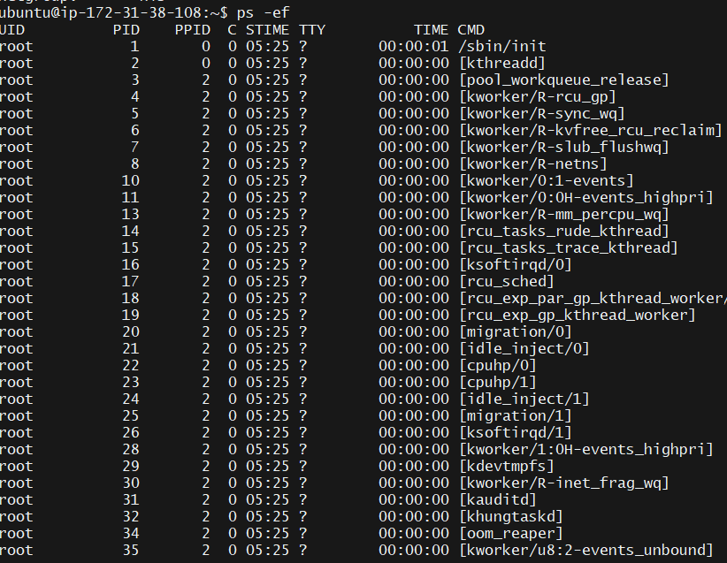
Why this matters (This unlocks Docker)
A Docker container is not a mini OS. A Docker container is just a group of isolated Linux processes.

- ps -p 1 -o pid,ppid,cmd
Running this command – you will see process with PID 1
In real server – PID 1 = systemd (OS INIT System)
In a container PID 1 = the application itself

In Kubernetes:
POD = a Linux Sandbox
Container = a process
Kubernetes is literally a process orchestrator built on Linux Kernel features.

PID – process ID: every running program in Linux gets a number.
A container is a process that thinks it owns the machine.

Linux kernel tricks the process into believing:
- it has its own filesystem
- its own network
- its own processes
But it actually shares the host kernel.

PPID – parent process ID
Linux processes always form a family tree. Everything ultimately comes from PID 1.

In a real server:
systemd (PID 1)
├── sshd
│ └── your shell
│ └── ps
└── docker
└── containerd
└── nginx
In Kubernetes this becomes:
systemd
└── kubelet
└── container runtime
└── pod container (your app)

SIGNALS – This is what actually stops containers & PODS.

Linux talks to processes using signals.
SIGTERM – please shut down gracefully.
SIGKILL – die immediately
SIGHUP – reload configuration
SIGSTOP – pause.

This is EXACTLY what happens:
Docker stop
- send SIGTERM
- wait 10 seconds
- send SIGKILL

kubectl delete pod
- Kubernetes – kubelet
- Kubelet – container runtime
- Runtime – sends SIGTERM
- Wait 30 seconds
- Send SIGKILL

Kubernetes field:
securityContext.runAsUser – LINUX UID
fsGroup – Linux group ownership
readOnlyRootFilesystem – remove write permission
secret mount failure – permission mismatch

chgrp appgroup /data/secret.txt - This is a very important Linux command, and it connects directly to how Kubernetes fsGroup works.

What chgrp actually does: Change Group

It changes group ownership of a file or a directory. Every file in Linux has 2 owners :
- User owner (one person)
- Group owner (a team)
Why this is powerful:
Instead of giving full root access or making files public, you create a controlled team access.

Now, connect this to Kubernetes:
securityContext:
fsGroup: 2000

Kubernetes does equivalent of :
chgrp 2000 <mounted-volume>
chmod 600 <files>
So your container user (UID 1000) can read secrets/configmaps without running as root.

Simple analogy:
- Owner – house owner
- Group – family members
- Others – strangers

chown - transfer house ownership
chgrp – allow family access
chmod – lock/unlock doors.

Why this matters in Docker & Kubernetes:
USER 1001
When a containers runs as user 1001, but files inside the image are owned by root.
The app cannot:
- Write logs
- Create temp files
- Update cache
Container starts -> fails -> restarts -> CrashLoopBackOff
The fix DevOps engineers use:
RUN chown -R 1001:1001 /app

Why using chmod 777 is dangerous:
Imagine web server directory :
/var/www/html

You run – chmod -R 777 /var/www/html

Now, any user/process on the machine can:
. replace your website files
. inject malware
. upload a reverse shell
. modify login page
. steal credentials
Networking
- ip addr – lo: 127.0.0.1
This is the computer talking to itself. When an app connects to localhost, it never leaves the machine. The packet never touches a network card.
- eth0 – the containers real network card. This is your containers virtual ethernet interface. But…there is no physical cable. How?
Linux uses a kernel feature called – Network Namespaces. The Kernel creates a completely separate network world for the process (container). Your container thinks –
. it has its own NIC
. its own IP
. its own routing table. But its virtual.

One very important realization. You are not inside fake machine. You are: A normal Linux process placed inside separate namespaces.
(filesystem + process + network)
A container = Linux isolation features combined:

. PID namespace
. Mount namespace
. Network namespace
. User namespace
. cgroups

No hypervisor. No VM

Cgroups – the real power behind Kubernetes resource limits
Kubernetes itself does not control CPU & memory. The Linux Kernel does – using cgroups.

First, the real problem containers created.
Before containers existed, imagine a server. You deploy 5 applications.
One buggy Java app suddenly consumes all RAM.
What happens?
. OS memory exhausted
. swap thrashing
. other apps freeze
. SSH stops
. server dead

Linux needed a way to say – This process can consume only this much resources. The solution – CGROUPS or Control Groups.
cgroups = resource quota for processes.

Linux can group resources and assign limits:
. RAM Limit
. CPU Limit
. disk I/O limit
. process count

A container is simply a group of processes placed inside a cgroup.

- cat /proc/self/cgroup.

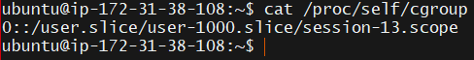

Everything in Linux is a file.
/proc – not a real directory. It is a live view into kernel memory.
/proc/self – information about the current running process (your bash)
So /proc/self/cgroup – shows which resource group your shell belongs to. This is the invisible fence around your container.

Now, how Kubernetes uses this. When you write:

resources:
requests:
memory: "256Mi"
limits:
memory: "512Mi"

Kubernetes does not enforce it directly. Instead,
kubelet → container runtime → Linux kernel → cgroups
The kernel then says: this group of processes cannot exceed 512 mb RAM.

If the memory exceeds, then Linux executes:

OOM Killer – Out of Memory Killer.
This is a kernel protection mechanism. When memory is exhausted, Linux chooses a victim process & kills it.

In containers:
The victim is the container’s main process – PID 1
Kubernetes sees process died – restarts pod.
If you see:
- OOMKilled
- CrashLoopBackOff

Not a Kubernetes error. A Linux Kernel decision.

Why Kubernetes kills the container
If Linux didn’t do this: One pod could consume all RAM & kill,
. kubelet
. container runtime
. networking
. the entire node
So OOMKilled is actually a safety feature.

Memory
- free -h

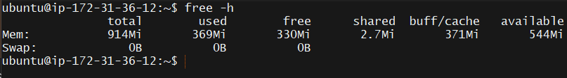
cat /proc/meminfo | head
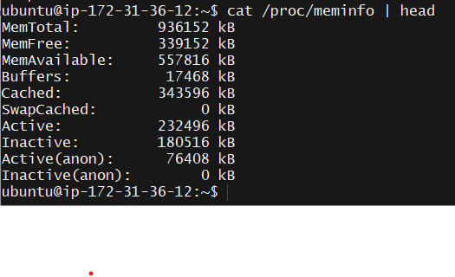
Here, you are reading RAM information directly from the Kernel.
No monitoring tool needed.

The most important mental model:
Pod – process group
Container – process
Limits.memory – cgroup memory limit
Limits.cpu – cgroup CPU quota
OOMKilled – kernel OOM Killer
Node pressure – host memory exhaustion

Kubernetes is basically a very smart automation layer over Linux kernel features.

Why Java apps often get OOMKilled
Classic production issue:
Java sees node has 16GB RAM → allocates 12GB heap.
But Kubernetes limit is 512MB.
Kernel kills it instantly.
Because JVM reads host memory, not cgroup memory (older Java versions especially).
This is one of the most common real-world incidents.

- cat /proc/self/cgroup
output - 0::/user.slice/user-1000.slice/session-1.scope

That snippet is basically your shell pulling its own "ID card" from the Linux kernel to see which resource bucket it belongs to.
When you run cat /proc/self/cgroup, you are asking the kernel: "Which control groups (cgroups) is this specific process currently restricted by?"

Breaking Down the Output
The output 0::/user.slice/user-1000.slice/session-1.scope follows a specific format required by cgroup v2 (the modern standard for Linux resource management):
- 0 (Hierarchy ID): In cgroup v2, there is a single unified hierarchy, so this ID is always 0. (In the older v1, you’d see multiple lines with different numbers for CPU, memory, etc.).
- :: (Controllers): Since it's unified, the specific controllers (like cpu or memory) aren't listed individually here; they are all managed under this one path.
- /user.slice/user-1000.slice/session-1.scope (The Path): This is the "address" of your process within the system's resource tree.
- What those "Slices" and "Scopes" actually mean:
- Systemd uses these terms to organize your computer's resources:
Term | Meaning
user.slice | The broad container for all logged-in users.
user-1000.slice | Resources dedicated specifically to your user ID (1000 is usually the default for the first human user, "ubuntu").
session-1.scope | A "scope" is a transient group for processes started externally (like your SSH login session). This is where your current Bash shell lives.

To see the actual limits being enforced on your session, we need to look at the cgroup controller files. Since your output showed you are on cgroup v2, these files are located in /sys/fs/cgroup/.
The path you found (/user.slice/user-1000.slice/session-1.scope) is a sub-directory within that location.
1. Find your specific limit folder
You can jump straight into that directory to see the "knobs" the kernel uses to throttle your processes:
cd /sys/fs/cgroup/user.slice/user-1000.slice/session-1.scope/
ls

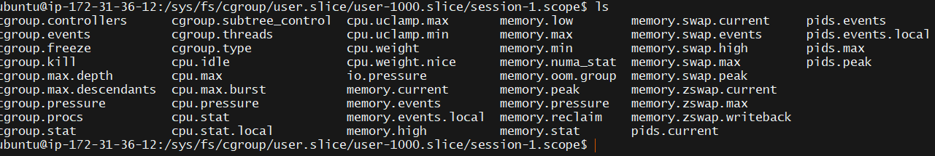
Quick Command: To see your current memory usage in a readable format (MB), run this while in that directory:

echo "$(( $(cat memory.current) / 1024 / 1024 )) MB"
Instead of manually editing system files (which usually requires root and can be messy), the cleanest way to apply limits to a script or command is by using systemd-run. This creates a temporary "transient" cgroup just for that specific task.
The "Sandbox" Command
If you have a script (let’s call it heavy_script.sh) and you want to ensure it never crashes your whole system by eating all the RAM, you can run it like this:

systemd-run --user --scope -p MemoryMax=100M -p CPUQuota=20% ./heavy_script.sh

How to Verify it's Working
While that limited script is running, open a second terminal and check your cgroup list again:
cat /proc/self/cgroup

To see how close you are to those limits in real-time, the best tool is systemd-cgtop. It’s like top, but for cgroups:
systemd-cgtop --user

To make these limits permanent, we use systemd user configuration. This ensures that every time you log in, or every time a specific service starts, the kernel automatically ropes those processes into the restricted cgroup you defined.
1. Limit your entire User Session
If you want to ensure that "User 1000" (you) can never accidentally use more than, say, 2GB of RAM or 50% of the CPU across all your combined processes, you modify your user slice.
You’ll need sudo for this part since it affects system-wide resource allocation:
sudo systemctl set-property user-1000.slice MemoryMax=2G CPUQuota=50%
What happens next:
- Systemd creates a "drop-in" file at /etc/systemd/system.control/user-1000.slice.d/50-MemoryMax.conf.
- This limit survives a reboot.
- Even if you open 10 different SSH terminals, their combined usage cannot exceed these numbers.
2. Limit a specific Background Service
If you have a specific app (like a web server or a bot) that you want to throttle permanently, you edit its .service file.
- Open the override file: systemctl edit my_app.service
- Add the limits:
[Service]
MemoryMax=500M
CPUQuota=10%
TasksMax=50

- Reload: systemctl daemon-reload

free -h (RAM status)

Total – the physical RAM installed/allocated – 914Mi (~1 GB)
Used – What your apps & OS are actively using – 351Mi
Free – Memory that is doing absolutely nothing – 348Mi
Buff/Cache – Smart memory usage (speeding up your disk) – 372Mi
Available – The most important number. Total minus what is actually needed – 562Mi

Understanding "Available" vs "Free"
New users often panic seeing “Free” memory get low, but Linux is designed to use RAM to make your computer faster.

Buff/Cache: Linux sees your unused RAM and thinks, "I'll use this to store files I've recently read so I don't have to go back to the slow disk next time." * Available: If an app suddenly needs memory, Linux will instantly "evict" the cache and give it to the app.

Rule of thumb: As long as Available is healthy, your system is fine.

The “Swap” section
Swap: 0B 0B 0B
This is a red flag for a small 1GB instance. Swap is "emergency RAM" located on your hard drive. If your apps exceed the 914Mi of real RAM, the system has nowhere to go. Without Swap, the Linux kernel will trigger the OOM Killer (Out Of Memory Killer), which will pick a process (like your web server or database) and crash it instantly to save the OS.

Your System’s status
Current Load: You are using about 38% of your RAM. You have plenty of room for small tasks.
Risk: Because you have 0B Swap, if you run a memory-heavy command (like a large npm install or a Java app), your session will likely freeze or the process will be killed immediately.

The Shared memory field – 2.7Mi is a specialized category. In modern Linux, it primarily refers to memory that is being used by more than one process simultaneously.

What is actually in “Shared” memory:
Most of 2.7Mi is living in tmpfs (a temporary filesystem that looks like a disk but is actually stored in RAM). Common things found here include:

. Inter-process communication (IPC): When two different programs need to "talk" to each other by reading from the same memory space.
. Shared Libraries: If you have five different programs all using the same system library (like libc), the kernel only loads one copy into RAM and "shares" it across all five.
. Systemd/D-Bus: Small messages sent between background services.

How it affects your “Used” total
There is a bit of "double-counting" math happening under the hood that Linux handles for you:
. The Shared memory is technically part of the Used column.
. It is also counted as part of the Buff/Cache column (specifically the "Cached" portion).

Why is yours so low (2.7 Mi)?
On a desktop computer (like Ubuntu with a GUI), the Shared value is often 100Mi to 500Mi because the window manager and graphics drivers share huge amounts of data to draw windows on your screen.
On your ip-172-31-36-12 (an AWS EC2 instance), you aren't running a screen or a mouse. You are likely just running a shell and a few background services. 2.7 Mi is extremely lean and efficient—it means your processes aren't holding onto large shared data structures.

To see exactly what is making up that 2.7 Mi of shared memory, we use the df (disk free) command. On Linux, shared memory is almost always mounted as a virtual filesystem called tmpfs.

df -h | grep tmpfs

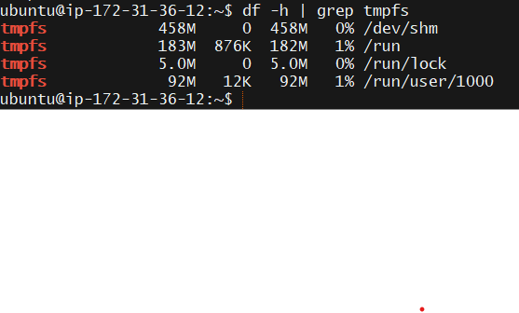

The "Shared" Culprits:
The 2.7 Mi from your free -h output is the sum of the Used column for these specific locations:
- /run: This is where the OS stores "runtime" data—things like process IDs (PIDs) and "lock" files that prevent two programs from trying to use the same hardware at once.
- /dev/shm (Shared Memory): This is the most common place for "Shared" memory. High-performance apps (like databases or Chrome) use this to pass raw data between processes at lightning speed. Since yours is likely 0B, your server is running very "lean."
- /run/user/1000: This contains tiny temporary files specifically for your login session (like your SSH agent info).

One final check:
If you want to see the specific files inside that 2.7 Mi, you can peek into the /run directory:
ls -lS /run | head -n 10
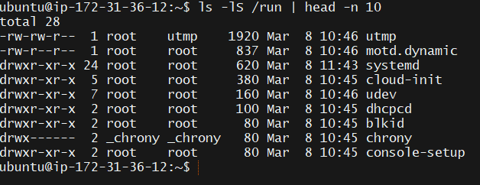
Buff/cache – very important
Linux uses spare RAM as a disk cache. Why?
Because RAM is ~100x faster than disk. So Linux keeps:
. recently opened files
. binaries
. libraries
. container images
. logs
In memory so next time they load instantly.
Example:
First time you run kubectl -> slow
Second time -> fast.

Because it came from RAM cache. Cache memory is automatically freed when an application needs RAM. So this memory is reusable. This is why Linux almost never keeps RAM empty.

SWAP Section
Swap = disk used as backup RAM
When RAM fills, Linux moves inactive memory pages to disk. But swap is slow.
Good sign – 0B used – your system is not under memory pressure
Bad production sign – swap heavily used – server is struggling

Why this matters for Kubernetes:

Kubernetes watches available memory on the node. If it becomes low,
Node condition: MemoryPressure=True
Then Kubelet – stops scheduling pods, evicts pods, kernel OOM killer may activate.

So OOMKilled is not random, it starts here.

Quick Mental Model-
Used – workers actively using space
Buff/cache – pre-loaded materials for speed
Available – space you can still accept shipments

Linux kernel separates resources into controllers:
Memory – RAM usage
Cpu – cpu time
Pids – numbers of processes
Blkio – disk I/O speed
Cpuset – which CPU cores you can run on
Devices – which hardware devices you can access
So your container is not a fake machine. It is a group of processes with resource quotas enforced by the kernel.

This is EXACTLY what Kubernetes limits does

When you write:
resources:
limits:
memory: "512Mi"
cpu: "500m"

Kubernetes does not implement memory control itself. Instead it instructs container runtime:

Create cgroup → attach container processes → apply limits
How kernel chooses who to kill
Linux assigns every process a score:
oom_score
cat /proc/1/oom_score
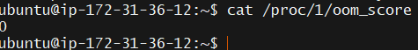
Higher score -> more likely to be killed.
Containers typically have higher scores then system processes.
Why?
Because Linux prefers:
- Keep system alive
- Sacrifice user workload
So the Kernel saves:
- ssh
- kubelet
- networking
and kills your pod.

Real Production Story:
This happens daily in companies. A microservice memory leak:
- slowly consumes RAM
- crosses limit
- kernel kills container
- Kubernetes restarts pods
Users see: CrashLoopBackOff

Developers blame Kubernetes:
SRE checks: kubectl describe pod – Reason: OOMKilled
Root Cause: application memory leak.

Important Understanding:
Containers do not fail randomly. Almost every container restart is one of:
- Process exited
- Healthcheck failed
- Signal received
- OOMKilled
And 2 out of 4 are purely Linux behaviour

cat /proc/1/status | grep VmRSS

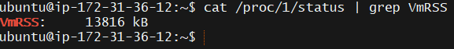
This will show – how killable your container is, how much RAM it is currently using. VmRSS – how much RAM your container is actually using. VmRSS – Resident Set Size.
This means: Real physical RAM currently occupied in memory (not virtual memory). So your bash process (PID 1 in this container) is using only about: ~13MB RAM.
That’s why containers are lightweight, A VM would need 100s of MB just to boot an OS.
This is one reason Kubernetes can run 100s of containers on 1 node.
oom_score – 0
This is very important. Linux assigns every running process a number from: 0 – almost never kill, 1000 – kill first

The higher the score -> the more likely the kernel will kill it during memory pressure. So your container, is a preferred victim. And that’s intentional.
Linux protects:
- System processes
- Ssh
- Networking
- Kubelet
And sacrifices – user workloads (containers). This is exactly why in Kubernetes: The pod dies but the node survives. Without this, a single memory leak could crash the entire cluster node.
Why Kubernetes shows OOMKilled
Now the full chain:
Application allocates too much RAM
↓
cgroup memory limit exceeded
↓
Linux OOM killer selects highest oom_score process
↓
PID 1 (container main process) killed
↓
Container exits
↓
kubelet notices container stopped
↓
Pod restarted
You see:
State: Terminated
Reason: OOMKilled

Kubernetes didn’t kill it. Linux kernel did. Kubernetes just reported it.

A critical production insight
Many people increase CPU when pods restart. But OOMKilled is not CPU problem. It is always, application memory usage > memory limit.

Correct fixes are:
. increase memory limit
. fix memory leak
. tune JVM heap
. adjust cache size

Now CPU Limits – Another mystery

Memory limit -> hard wall (kernel kills process)
CPU limit -> different behaviour.
Linux does not kill a process when CPU exceeds limits.
Instead, it uses:
CPU Throttling, meaning:
The Kernel slows down the process. So, a container hitting the CPU limit does not crash. It becomes slow.
This explains a very common production complaint. –
“Pods are running but response is 15 seconds”
Node CPU looks free -> but container CPU limit reached.

How Linux enforces CPU limits
cgroups assign each container a time slice.
Example:
1 CPU core = 100%
500m CPU in Kubernetes= 50%
The Kernel scheduler only allows that process to run for half the time. So, your app:
. not killed
. just paused repeatedly.
This is called CPU throttling.

Why this matters:
Now, Kubernetes behaviour makes sense.
Memory exceeded -> kill process.
CPU exceeded -> slow process.

So, OOMKilled -> crash; CPU limit -> latency.

You now understand,
Linux Kernel -> cgroups -> Docker -> Kubernetes resources -> Pod restarts. This is literally backbone of container orchestration.

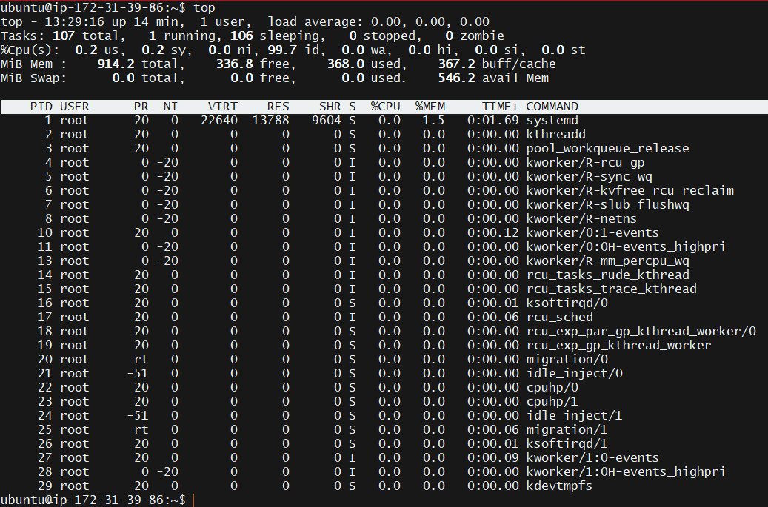
When a productions server becomes slow, the very first command an SRE runs is: ‘top’.

First line — Processes

‘top’ – who is consuming the machine?
Tasks: 107 total, 1 running, 106 sleeping, 0 stopped, 0 zombie

total – number of processes
running – currently executing on CPU
sleeping – waiting for CPU/event
zombie – dead but not cleaned (bad sign normally)

Second Line – CPU section
%Cpu(s): 0.2 us, 0.2 sy, 0.0 ni, 99.7 id, 0.0 wa, 0.0 hi, 0.0 si, 0.0 st

us – user programs (apps)
sy – kernel work
id – idle CPU
wa – waiting for disk (VERY IMPORTANT)
st – stolen by hypervisor (cloud VMs)

Important Tip:
If you ever see: wa > 20% -- It means Disk I/O bottleneck (very common in databases & Kubernetes nodes)

Third Line - Memory Section

MiB Mem : 5783 total, 4115 free, 1012 used, 893 buff/cache
MiB Swap: 2048 total, 0 used
This matches what you saw in ‘free -h’
Key interpretation:
. plenty of RAM available
. swap unused
. system healthy.
An SRE would immediately conclude:
Node memory pressure = NO
So, OOMKilled would not happen right now.

Fourth Line – Process Table
This shows which process is consuming resources.

Why top is crucial in Kubernetes debugging
Imagine a node problem: Pods restarting. You SSH into the node and run ‘top’.
You see: java 390% CPU
You instantly know: one pod is hogging (CPU cores)
OR –
Python 8GB MEM
- Memory leak inside container.

Kubernetes logs won’t tell you that. Linux will.
Very important keys inside ‘top’.

P – sort by CPU
M – sort by memory
1 – show each CPU core
k – kill a process
q – quit

The big connection:
Symptom | Linux observation | Kubernetes effect
High memory process | seen in top | OOMKilled
High CPU | seen in top | latency
Disk wait high | wa% high | pod timeouts
Many processes | pids limit | container crash

‘lsof -i’ – list open files. In Linux, everything is a file. And that includes:
. network sockets
. TCP ports
. UDP ports
. pipes
. devices
So, a network port is literally just a special file handled by the kernel. ‘lsof -i’ – asks the kernel – Show me which processes opened network sockets.

Let’s create a real example:
We’ll start a fake server inside the container.

apt install -y netcat-openbsd

Now, start a listener.
nc -l -p 8080

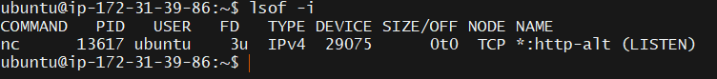
You just found:
. which process
. which PID
. which port

lsof -i :8080

Another very common production problem:
You restart nginx: systemctl restart nginx
It fails, reason? Port 80 is still in use.

Alternative modern command.

ss – tulnp

COMMAND PID USER FD TYPE DEVICE SIZE/OFF NODE NAME
nc 13450 ubuntu 3u IPv4 26220 0t0 TCP *:http-alt (LISTEN)

main part: *:http-alt (LISTEN)
http-alt = port 8080
Linux translated the number into a service name using: /etc/services
sudo cat /etc/services | grep -i http
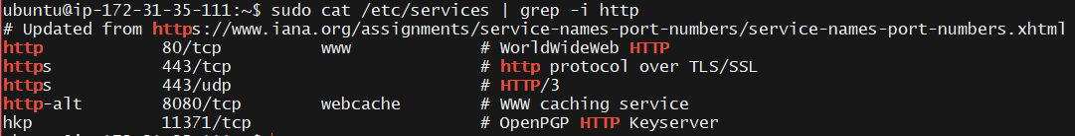
80 – http
443 – https
22 – ssh
8080 – http-alt

First Concept: Linux never stays silent

Every important thing happening in the system is recorded somewhere:
- login attempts
- ssh failures
- disk errors
- service crashes
- network problems
- kernel panics
- container failures
Linux writes them all into log files. And almost all of those live in one place:

/var/log

Important log files:
/var/log/syslog – general system activity
/var/log/auth.log – login & sudo attempts
/var/log/kern.log – kernel messages
/var/log/dmesg – boot hardware messages
/var/log/apt – package installation issues.

Always use ‘less’ command to read logs.

less /var/log/auth.log

Inside ‘less’:
Shift + G – jump to bottom (most recent logs)
/word – search
q – quit

Most used command:
tail -f /var/log/syslog

Demonstrate live logs capture:

In one terminal:
tail -f /var/log/dpkg.log

Now, open another terminal & type:
sudo apt install -y tree

You can see live logs captured in 1st terminal.

Another extremely important command:
dmesg | tail

dmesg shows kernel messages.
- memory problems
- disk failures
- device errors
- OOM Killer activity.
When a Kubernetes node crashes, SREs check this immediately.
In fact, OOMKilled events appear here from the kernel first.

kubectl describe pod – OOMKilled
That information originally came from:
- Linux kernel
- Logged in kernel ring buffer
- Kubelet read it
- Kubernetes displayed it

Key skills gained so far,
Server slow – top
Server not starting - /var/log/syslog
Login issues - /var/log/auth.log
Node crash – dmesg
Pod restart – kubectl logs + kernel messages.

Inside containers, /var/log/syslog may even be empty or missing.
Why? Because, containers usually do not run a logging daemon – no rsyslog, no systemd-journald.
Instead, containers log to: stdout & stderr
And Docker/Kubernetes capture that output. kubectl logs pod – is acutally reading the containers standard output stream not /var/log/syslog.

Traditional Linux Servers Containers
-log written to files -logs written to console
-syslog daemon -container runtime
-tail /var/log/syslog -kubectl logs

Now: How Linux Logging ACTUALLY Works (Real Server)
On a real Linux machine there are three layers of logs:

Applications -> systemd-journald (primary logger) -> rsyslog (optional but common) -> /var/log files.

So, /var/log/syslog is actually the last stage, not the first.
The real brain is:
Journald (systemd journal) – This is the modern Linux logging system.

Step 1 – Check system boot logs
journalctl -b | head

You are literally reading the messages produced while the server was booting. This includes:
. kernel startup
. disk detection
. network initialization
. cloud init
This is the first place SREs check when a server doesn’t start properly.

Step 2 – Live logs
sudo journalctl -f – this is equivalent to - tail -f /var/log/syslog

Now, open another SSH session & do:
sudo systemctl restart ssh

Step 3 – service specific logs
Instead of reading 10000 lines, you can filter by service.

sudo journalctl -u ssh
This shows only SSH daemon logs

Step 4 – login/security logs
sudo journalctl -u ssh -n 20

Step 5 – dmesg | tail

Step 6 – actual log files
cd /var/log
You will finally see:
- syslog
- auth.log
- kern.log
- dpkg.log
- cloud-init.log

Now the BIG Kubernetes connection
When you SSH into a Kubernetes node and something is wrong (node NotReady), engineers check:
journalctl -u kubelet
journalctl -u containerd
dmesg

Linux Quick Revision Cheat Sheet
- Navigation & Filesystem (very basic but always asked)
Command | What it does
pwd | show current directory
ls | list files
ls -l | detailed listing (permissions, owner)
cd | change directory
cd .. | go up one level
ls / | view root filesystem
touch file | create empty file
cat file | print file
less file | read large file safely
nano file | edit file

Interview question they love:
“Difference between / and /root?”
Answer: / is filesystem root, /root is root user’s home directory.

- Users, Permissions & Ownership (VERY IMPORTANT — asked a lot)
Command | Purpose
whoami | current user
adduser / useradd | create user
su - user | switch user
chmod | change permissions
chown | change owner
chgrp | change group

Very common interview question:
Why does a container fail with “Permission denied”?
→ UID/GID mismatch with mounted volume.

- Processes & Signals (this is where DevOps candidates usually fail)
Command | Purpose
ps -ef | list processes
top | live CPU/memory usage
kill PID | graceful stop (SIGTERM)
kill -9 PID | force kill (SIGKILL)

SIGTERM → graceful shutdown
SIGKILL → immediate death
Kubernetes connection:
kubectl delete pod → sends SIGTERM first.
- System Monitoring (VERY IMPORTANT in interviews)
Command | What it checks
top | CPU usage
free -h | memory usage
df -h | disk usage
dmesg | kernel errors
uptime | system load

The BIG interview trap
They show:
RAM 90% used
Correct response:
→ Check available memory, not used (Linux caching).

- Networking (extremely important for DevOps)
Command | Use
ip addr | show IP address
ss -lntp | show listening ports
lsof -i | which process uses a port
ping | connectivity
curl | test HTTP service
hostname | machine name

Critical interview question:
Why can pod reach service but not external?
→ DNS, routing, or network policy.

- Logs (real production skill)
Command | Purpose
journalctl | system logs
journalctl -u ssh | service logs
journalctl -f | live logs
tail -f file | live file logs
/var/log/auth.log | login attempts
dmesg | kernel & OOM events

Kubernetes mapping
kubectl logs = container stdout

- Storage & Filesystem (VERY IMPORTANT for Kubernetes)
Concept | What it explains
mount | attach disk to folder
overlayfs | container filesystem
tmpfs | memory filesystem
volumes | persistent storage

Key idea
Containers lose data because writable layer is temporary.
- cgroups & Resources (VERY HIGH VALUE TOPIC)
Resource | Kernel action
memory limit exceeded | OOM kill
CPU limit exceeded | throttling

This directly explains:
OOMKilled
CrashLoopBackOff

Topic 1 — Package Management (APT)

Your server has a list of official software sources here:
Run : cat /etc/apt/sources.list
You will see Ubuntu repository URLs.
That means:
When you install a package, Linux does NOT search Google.
It asks Ubuntu’s servers.
What apt update REALLY does
This is a very commonly misunderstood command.
sudo apt update - does not update the system. It only does:
“Download the latest list of available software versions.”
Think of it as refreshing the app store catalog.
Your server downloads metadata like:
- nginx 1.24 available
- curl 8.5 available
- openssl security patch available
Without this step, the system installs old versions.

apt update – refresh package list
apt upgrade – actually upgrade installed software

When you run:
sudo apt install nginx.
Linux performs:
- resolves dependencies
- downloads packages
- verifies signatures (security)
- extracts files into filesystem
- registers service with systemd
- starts service automatically.
So, installation also creates and starts a service.

Now, we enter most important Linux concepts:
systemd – the service manager
You saw earlier:
. ssh automatically starts
. nginx automatically started
How? Linux has a supervisor program called systemd
systemd is basically the manager of background services.
Everything important runs as a service.
- sshd
- nginx
- docker
- kubelet
- containerd
Kubernetes nodes also depend on systemd.
Now the powerful debugging command
journalctl -u nginx – this shows only nginx logs.
This is exactly how we debug failing services.
In real life:
journalctl -u kubelet
journalctl -u docker
journalctl -u containerd

The Linux DNS resolution order (VERY IMPORTANT)
Linux follows a specific lookup chain:

Application
↓
/etc/nsswitch.conf
↓
/etc/hosts
↓
DNS Server (/etc/resolv.conf)
↓
Internet DNS (AWS / ISP / Cloudflare / Google)

Step 1 - /etc/hosts (local DNS)
cat /etc/hosts - 127.0.0.1 localhost.
This file is a manual DNS override. Before asking any DNS server, Linux checks this file first. Meaning, you can create fake DNS locally. Edit vim /etc/hosts – add 1.2.3.4 mytestsite.
You can run: ping mytestsite. It will try to reach 1.2.3.4.
You just became a DNS server.

Step 2 - /etc/resolv.conf (real DNS servers)
cat /etc/resolv.conf – nameserver 127.0.0.53. This surprises many people. You expected 8.8.8.8 (Google DNS). But this means, your machine is not directly querying Google DNS. Instead, Ubuntu uses a local DNS resolver called: systemd-resolved.

Your machine asks a local DNS cache -> which asks AWS DNS -> which ask the internet.
We can see the real upstream DNS:
sudo resolvectl status -> You will see AWS internal DNS like:
172.31.0.2 – This is Amazon VPC DNS.

Why this matters in Kubernetes
Kubernetes uses the same idea.
Instead of AWS DNS, pods query: CoreDNS
Linux | Kubernetes
/etc/hosts | pod hosts file
systemd-resolved | CoreDNS
DNS server | kube-dns service
domain resolution | service discovery

This is how: “my-service.default.svc.cluster.local” works.
Not magic – just DNS.

Now the MOST IMPORTANT FILE (often asked in interviews)
Open:
cat /etc/nsswitch.conf
Find this line:
hosts: files dns

This line defines lookup priority:
Word | Meaning
files | check /etc/hosts first
dns | then check DNS server
If this line is wrong → name resolution breaks.
This actually happens in broken Kubernetes nodes.

Real Production Issue:
ping 8.8.8.8 – works
ping google.com – fails
Meaning, network is fine, DNS is broken.
Engineers immediately check,
cat /etc/resolv.conf
resolvectl status
systemctl status systemd-resolved

And, often restart:
sudo systemctl restart systemd-resolved.

Step 1 — /etc/nsswitch.conf (the decision maker)
You got:
hosts: files dns
This single line controls the entire lookup order.
It means Linux resolves a hostname in this order:
1) /etc/hosts
2) DNS server
So, when you type:
ping google.com
Linux does NOT immediately contact a DNS server.

First it checks:
/etc/hosts
Only if not found → it queries DNS.
That is why your entry:
1.2.3.4 mytestsite
worked instantly — no network request happened.

Step 2 — /etc/hosts (local override DNS)
Your file:
127.0.0.1 localhost
1.2.3.4 mytestsite
This file is basically a manual DNS table.
You can override any website:
Example:
Example:
142.250.x.x google.com
Now your machine would redirect Google to a different IP.
Developers use this all the time to test services before real DNS exists.

Why this matters in Kubernetes
Inside every pod Kubernetes also creates a hosts file.
Example (inside pod):
10.96.0.1 kubernetes.default.svc
This is how the pod finds the Kubernetes API server even before DNS queries happen.
So Kubernetes literally uses the same Linux mechanism.
Step 3 — /etc/resolv.conf (real DNS resolver)
You saw:
nameserver 127.0.0.53
search ec2.internal
This confuses almost everyone the first time.
It looks like:
“My server is using itself as DNS?”
Correct — but not really 😄
127.0.0.53 is a local DNS cache service called:
systemd-resolved
Your server sends the DNS request to a local resolver, and that resolver forwards to AWS DNS.
So, the real chain is:
Application
→ systemd-resolved (127.0.0.53)
→ AWS VPC DNS (172.31.0.2)
→ Internet DNS
→ Answer comes back

The search ec2.internal line (VERY IMPORTANT)
This is a big cloud concept.
It means:
If you type:
ping ip-172-31-73-138
Linux automatically tries:
ip-172-31-73-138.ec2.internal
So short names work inside AWS VPC.

Now the important Kubernetes connection
Kubernetes does the SAME thing.
Pods have this:
search default.svc.cluster.local svc.cluster.local cluster.local
So inside a pod, if an app connects to:
http://redis
Linux automatically expands:
redis.default.svc.cluster.local
Then CoreDNS returns the service IP.
That is literally how microservices talk to each other.
No service registry magic — just DNS.

What REALLY happens when you type:
curl google.com
Linux does not literally “travel file-to-file”.
Files are only configuration rules.
Instead, the application asks the OS:
“Hey Linux, please give me the IP address of google.com”
Linux then follows a resolution procedure defined by:
/etc/nsswitch.conf
This file is actually the brain of name resolution.
You saw:
hosts: files dns
That line means:
First check local files → then check DNS server.
Now let’s walk the real flow step-by-step.

The real DNS resolution flow
Step 1 — Application asks OS resolver
curl → glibc resolver → Linux name resolution system
The program itself does not do DNS.
The OS resolver library does it.

Step 2 — Check /etc/hosts
Linux first opens:
/etc/hosts
and searches:
google.com
If found → DONE.
No network request happens.
Example:
1.2.3.4 google.com
Linux will immediately connect to 1.2.3.4.
This is why /etc/hosts is called a local override, not a full DNS server.
Step 3 — Not found → check DNS configuration
Now Linux looks at:
/etc/resolv.conf
You had:
nameserver 127.0.0.53
Important:
That is not the real internet DNS.
It is a local DNS resolver service:
systemd-resolved
So the OS sends a DNS query to:
127.0.0.53 (local resolver running on your machine)

Step 4 — Local resolver forwards query
systemd-resolved now forwards the query to AWS DNS:
172.31.0.2 (VPC DNS server)
AWS DNS then queries the public DNS hierarchy:
Root DNS → .com → Google DNS authoritative server
Google replies:
google.com → 142.250.x.x
The answer travels back the same way:
Google → AWS DNS → systemd-resolved → your OS → curl
Then curl connects to that IP.
Clean mental model
Here is the accurate chain:
Application
↓
OS Resolver (glibc)
↓
nsswitch.conf rules
↓
/etc/hosts
↓
/etc/resolv.conf (local resolver)
↓
systemd-resolved
↓
AWS DNS
↓
Public Internet DNS
↓
Response IP
↓
Application connects

SCP – Secure copy

Syntax:
scp -i path-to-your_private_key(.pem) path-to-yourfile username@public-dns-or-ip:/remote/destination/path/

sudo dmesg | grep -i "oom\|kill\|fail"

du -sh */
sudo dmesg -T – shows output(timestamp) in human readable format
journalctl -u nginx
journalctl -u nginx –-since “1 hour ago”
journalctl -u nginx -f – f streams the logs

sar -u 1 3 – to check cpu, memory utilization at particular time

DevOps Interview Angle
If interviewer asks:
“How do you check system performance?”
You can say:
I use top for quick overview and vmstat for deeper analysis of CPU, memory, swap, and I/O behavior.
That’s a strong answer.
Vmstat 1 5
sar -r 1 3 – memory
sar -n DEV 1 3 – network
ps aux --sort=-%mem
cat auth.log | grep -i -A2 -B2 cdrom -> here A2 – after 2 lines, B2 – before 2 lines

cat app.env
DB_HOST=10.0.0.5
DB_PORT=5432
DB_USER=appuser
DB_PASS=supersecret123
LOG_LEVEL=debug
MAX_CONNECTIONS=100

sed -n ‘/DB_PASS/p’ app.env
output – supersecret123

sed -i ‘s/supersecret123/””/’ app.env
output –
cat app.env
DB_HOST=10.0.0.5
DB_PORT=5432
DB_USER=appuser
DB_PASS=””
LOG_LEVEL=debug
MAX_CONNECTIONS=100

sed -i 's/LOG_LEVEL=debug/LOG_LEVEL=info/' app.env
cat app.env
DB_HOST=10.0.0.5
DB_PORT=5432
DB_USER=appuser
DB_PASS=""
LOG_LEVEL=info
MAX_CONNECTIONS=100

cat dpkg.log | awk -F " " '{print $1 $2 $3}'
cat dpkg.log | awk -F " " '{print $NF}' - this will print last line or field or element
cat dpkg.log | awk -F " " '{print $(NF-1)}' – this prints second last element
cat dpkg.log | awk -F " " '{print $NF}' | uniq -c
cat dpkg.log | awk -F " " '{print $NF}' | uniq -c | sort -rn
cat dpkg.log | awk -F " " '{print $NF}' | sort | uniq -c | sort -rn
find
sudo find / -type d -name "dist-upgrade"
same can be achieved by installing plocate , usage :
locate dist-upgrade
ls -R /var | grep dist-upgrade
if we want to find files > 50MB then,
sudo find / -type f -size +50M
curl -I http://localhost
sudo grep -i "PermitRootLogin\|PasswordAuth" /etc/ssh/sshd_config

mtr google.com
mtr –-report -c 10 10.0.0.5
tcpdump -i eth0 port 5432 -c 20
nmap localhost

Method 1: Adding to the Sudo Group (Recommended)
usermod -aG sudo devops – devops is the user we have created.
Another way:
Command - sudo visudo
Scroll down to the section where user privileges are defined.
Add following line:
devops ALL=(ALL:ALL) ALL

